Project “Island Escape” 1.5-Page GDD
Brief Summary or Hook

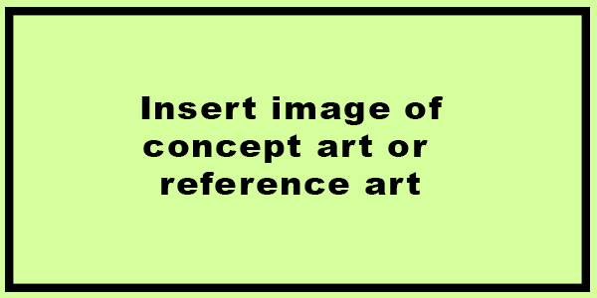

Genre: 3rd Person Action RPG, Single Player
Target Audience: 12+ RPG Fans
Controls: Mouse+Keyboard
Thematic Setting: Medieval Brazil / Portuguese crusaders and Native Indian Tribes.
Tech Stack: Unity 2018 w/ C#. Audacity for SFX. Blender for 3d art. GIMP for 2D/Images
Platform(s): Initially Steam. Potential to go to mobile.
MVP Game Moment: 5 minutes of gameplay containing the core game mechanics (combat against crusaders/nature, survival needs, dependants survival needs. Trading with Natives)

Game Summary: You and your family survived when a Slave Ship sinked near an island near the coast of Brazil. Now you are alone having to fight nature and the Portuguese crusaders raiding the brazilian territory, and also having to feed your wife and child’s mouth.
Thankfully, there are some native tribe indians to help you on your journey. Your only chance of survival is to team up with them to fight off the opressors and build a raft to reach the unexplored main land. Get ready, because you’ll need every resource that you have.

Core Player Experience: Survival/The feeling of being safe and protecting your loved ones.
Central Story Theme: The impossible escape.
Design Pillar: Putting the player in extremely hard situations. The need to explore the unknown to acquire advantages over your opponents.
Remarkability: The unlikely challenge of getting out of the situation alive.

Anticipated Steam Early Access Launch date: 2T 2021

Feature Development Priorities:
- Real-time Combat with Wild animals and humans.
- A mid-ranged variety of weapons to chose from.
- Slot/weight based inventory.
- Raft building system.
- Progressive access to certain areas.
- Intriguing quests.
- At least 30 minutes of gameplay.

Reference Games:

